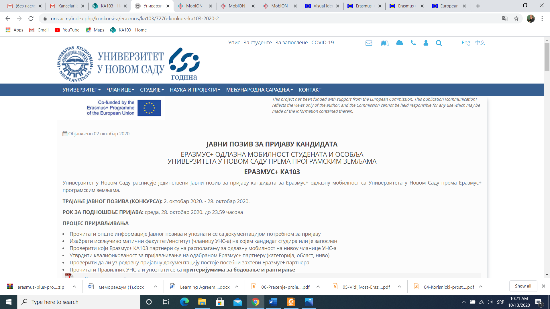

**Declaration form for the mobility of participants with disabilities in Erasmus+ mobility projects in higher education**

|  |  |
| --- | --- |
| **I**  **Data on the mobility participant** | |
| 1. Name and Surname |  |
| 1. Sending Institution |  |
| 1. Receiving Institution and country |  |
| 1. Type of the mobility |  |
| 1. Duration of the mobility |  |

|  |  |  |
| --- | --- | --- |
| **II Description of disability** | | |
| 1. Type of invalidity |  | |
| 1. Degree of disability |  | |
| 1. Need for a companion (indicate the period in which a companion is needed, as well as the amount of additional costs for companions) |  |  |
| 1. The need for health services/treatments during the mobility period (if any, state which and their amount) |  |  |
| 1. The need for special teaching aids (if any, state their amount) |  |  |

I, the undersigned, confirm that the information provided in the form is correct and complete.

Place and date _______________________

______________________________

Signature